Dear Development Team,
The X Land Use Committee (LUC) and the City of Victoria are located on the traditional territory of the lək̓ʷəŋən speaking people known today as the Songhees and Xwsepsum Nations. The LUC represents a neighbourhood comprised of X% of tenants and Y% of residents living in multi-unit housing and considers several key factors such as how a development will impact residents’ well-being, the environment, and biodiversity in the neighbourhood.
Earthly Invitation: The X LUC is asking you to assist with the recovery of the Garry oak ecosystem (GOE), recognized by the BC Government as an “ecosystem at risk.”

The urban forest of the City of Victoria is the Garry oak ecosystem (GOE), known in lək̓ʷəŋən language as the Kwetlal food system, which was dominant in Victoria before European settlement due in large part to thousands of years of lək̓ʷəŋən agroecological management. The Garry oak (GO), a long-lived keystone species, emerged after the glacial retreat around 10,000 years ago, and currently supports over 1,645 plants, insects, amphibians, reptiles, birds, and mammals, making its preservation urgent. GO and associated ecosystems have a unique local genetic adaptation that would be difficult to re-introduce if lost. GO is highly adapted to severe droughts and heat, including on rocky outcrops with shallow soil, and is of great importance in a changing climate for biodiversity and human health. In Canada, the GOE is unique to this region, some parts of the Gulf Islands and a few spots on the mainland (crd.bc.ca).
The scale of recent land use changes necessitates your assistance. With 75% of our urban forest on private land, there’s not enough public land to meet our essential canopy targets. The City of Victoria’s 2019 survey of urban forest canopy showed a city-wide average of 28%. The percent of canopy cover in the X neighbourhood is Z%. Collaboration and support from you and elected officials are essential. Traditional approaches to urban planning frequently devalue the crucial cultural, social, and environmental components of the GOE in the urban density discussion.
Developers must adhere to the City of Victoria Tree Protection Bylaw (TPB 21-035), yet there is room for improvement. Old-growth, pre-colonial settlement trees greater than 250 years of age persist and replacement is needed to establish the next generation. Between 2020 to 2023, only 68 replacement trees on private property were native species, compared to 354 introduced/exotic species, resulting in a 1:5 ratio (City of Victoria Open Data). In addition, plantable space is a variance, and not attached to legislation. Therefore, we ask for you to dedicate a minimum of 15% contiguous plantable space at every development site and consider planting native plants and trees as a tangible act of connecting with the territory. This will help achieve the minimum tree targets set forth by TPB 21-035 to maintain and steward a healthy canopy cover for the ecosystem over the next 30 years. The survival of the Garry oak ecosystem depends on your assistance.

Thank you for considering this invitation.

CITY OF VICTORIA 2019 TREE CANOPY ESTIMATES BY NEIGHBOURHOOD
Neighbourhood | Neighbourhood Area (Ha) | 2019 Tree Cover (Ha) | Percent of city-wide canopy
Burnside | 237 | 34 | 6%
Downtown | 77 | 7 | 1%
Fairfield | 297 | 92 | 17%
Fernwood | 175 | 56 | 10%
Gonzales | 136 | 53 | 9%
Harris Green | 24 | 4 | 1%
Hillside/Quadra | 166 | 57 | 10%
James Bay | 236 | 63 | 11%
North Jubilee | 63 | 19 | 3%
North Park | 56 | 12 | 2%
Oaklands | 173 | 54 | 10.5%
Rockland | 128 | 60 | 11.5%
South Jubilee | 38 | 11 | 2%
Victoria West | 157 | 36 | 6%
Total | 1963 | 558 | 100%
GARRY OAK ECOSYSTEM - WHAT REMAINS
Area | Year 1800 (Ha) | Year 1997 (Ha)
Victoria | 1,460 | 21
Oak Bay | 850 | 25
Saanich | 3,473 | 192
Central Saanich | 740 | 7
Sidney | 30 | 0
North Saanich | 1, 040 | 1
Esquimalt | 470 | 20
Colwood | 320 | 16
Langford | 370 | 105
View Royal | 270 | 39
Metchosin | 1,180 | 49
Indian Reserves | 240 | 37
Total | 10,443 | 512
Source: GOERT, http://goert.ca
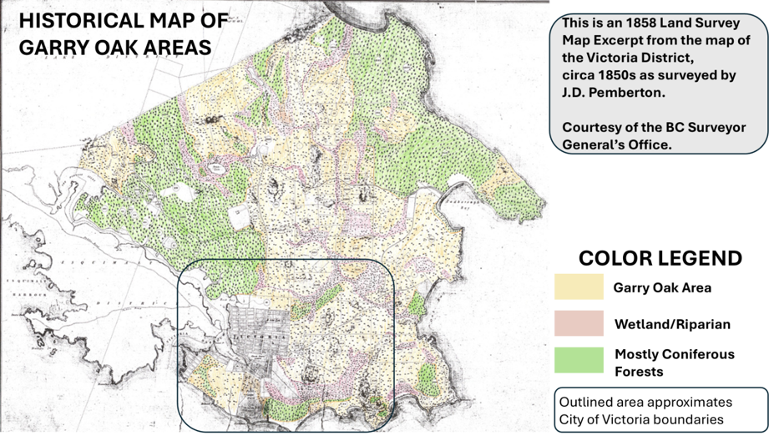  CITY OF VICTORIA  City of Victoria Tree Protection Bylaw  https://www.victoria.ca/media/file/tree-protection-bylaw-21-035  ENVIRONMENTAL ORGANIZATIONS  Garry Oak Meadow Preservation Society (GOMPS)  https://www.garryoak.info  Garry Oak Ecosystem Recovery Team (GOERT)  https://goert.ca  Native tree species: Garry oak, arbutus, shore pine, maritime juniper, pacific yew, pacific dogwood, western redcedar, bigleaf maple, cascara, black hawthorn, and Douglas fir. | NURSERY SUPPLIERS OF GARRY OAK  (List compiled February 2025)  Dinter Nursery  Lots of stock available. 3-to-7-gallon size. 2205 Phipps Road, Duncan, BC  250-748-2023  https://dinternursery.ca/ornamental-trees  Garry Oak Meadow Preservation Society Nursery  Lots of stock available. 1-to-2-gallon size.  5920 Patricia Bay Highway, Saanichton, BC  Grow.oaks@gmail.com  Satinflower Nurseries  Garry oak waitlist. Native plants available. Development site consultations for GOE resume Fall 2025. Short consultations at nursery still available.  747 Haliburton Rd, Saanich and 4286 Metchosin Rd, Metchosin. 778-679-3459  https://satinflower.ca  Garry Oak Meadow Native Plant List  https://goert.ca/wp/wp-content/uploads/GOERT-Gardeners-Handbook-2011.pdf

